The leading manufacturer of arc welding technology expands
EWM AG opens a location in France
EWM AG, Germany’s largest manufacturer of arc welding technology, opened a location in the city of Tours, France, on 4 April 2019. Managed by Stéphane Lemaire, a French national, the purpose of the location is to provide service and product training, demonstrations and welding support for France's welding technology professionals. The family-run company is thus keeping its word on staying close to its sales partners and customers with advice and service offerings – now in France as well. Alongside the company’s efficient arc welding technology tailored for customers’ requirements and a complete range of welding accessories, EWM is also offering new technologies for Industry 4.0 to the French market. Especially the Welding 4.0 welding management system ewm Xnet 2.0 used in combination with the new Titan XQ MIG/MAG multi-process welding machine yields a competitive advantage.

EWM has opened a location in Tours, France, to strengthen its presence in that country, providing a contact point for sales partners and customers. Located just an hour away from Paris, the site is centrally located and enjoys good infrastructure, including excellent road and rail accessibility, making it ideal for managing business relationships throughout France, Belgium and Luxembourg.
A team of ten is in charge of sales, demonstrations, training and back-office functions. All staff have a welding background and the necessary expertise. “There is a tremendous amount of interest in France in innovative, future-oriented welding technology. We can win companies over by delivering the highest quality, with recommendations from satisfied customers and with our guarantee promise: three years for welding machines and five years for rectifiers and transformers – with no operating hours limit, even in three-shift operation,” says Stéphane Lemaire, Manager France for EWM AG.

A compelling technology and service offering
The newly formed team in France functions as a technology partner to welders and metals companies, tradesman firms and industrial producers, providing support and developing complex arc welding technology solutions tailored to meet their needs. Users have the complete EWM AG technology and service offering at their disposal, including arc welding machines with all the necessary components, welding torches and welding consumables as well as accessories for manual and automated applications. “We follow our customers and have many loyal customers in France. And the challenges of the future are increasing day by day. This means having to provide ongoing training for our partners, our dealers, and our dealer network in order to keep them informed and able to impart state-of-the-art knowledge to our end customers. Our new ewm Xnet 2.0 quality management software – keyword: Industry 4.0/Welding 4.0 – brings digitisation to any company. All this has to be communicated properly on-site and in the local language,” says Robert Stoeckl, Executive Board Sales of EWM.

Innovative EWM welding processes demonstrably cut welding time by up to 15 percent for users while consuming up to a third less gas, with no loss of quality. The EWM forceArc puls® welding process can additionally cut welding smoke emissions by up to 75 percent versus conventional processes when working with high-alloy metals, such as CrNi steels.

Practical usage of digital welding technology
A number of live events were held throughout the day to celebrate the opening of the new location in Tours, including presentations of the new Titan XQ puls, the flagship in EWM’s line of MIG/MAG multi-process welding machines, and the Titan XQ 400 AC puls, the company’s new product for aluminium welding. EWM also conducted demonstrations of the Welding 4.0 welding management system ewm Xnet 2.0, showing how Industry 4.0 digital welding technology works in practical settings. The latest version of ewm Xnet 2.0 helps users with the digitally networked organisation of production, planning, quality management and coordination regarding welding as an all-in-one system. The opening day programme was rounded out by various activities, including a welding test for customers.

Contact data for the new EWM location in Tours, France:

EWM AG
Tours location
7 rue des Messagers
ZA de Chatenay
37210 Rochecorbon/Tours
France
Phone: +33 2 42 06 02 45
Email: info@ewm-france.fr

Dated: 8 April 2019
Volume: 4,435 characters including spaces (original text)
Photos: 4

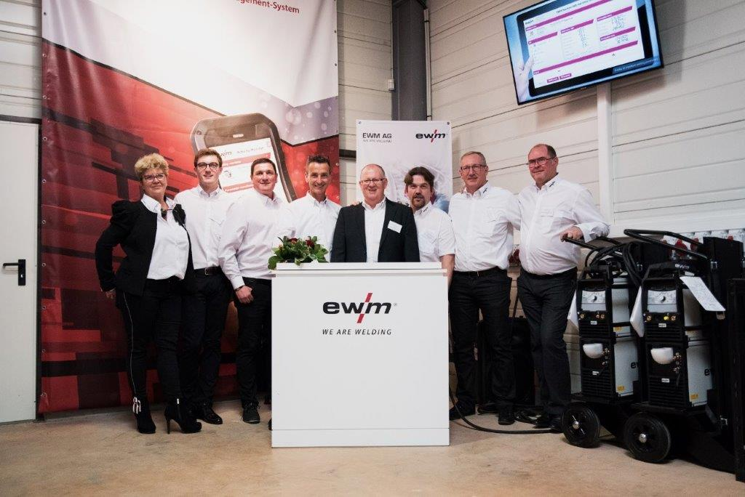Fig. 1:

The team at the newly opened EWM location in Tours, France, – here with Robert Stöckl, EWM Sales Director (centre) – is ready and waiting to tackle the tasks up ahead.

Fig. 2:
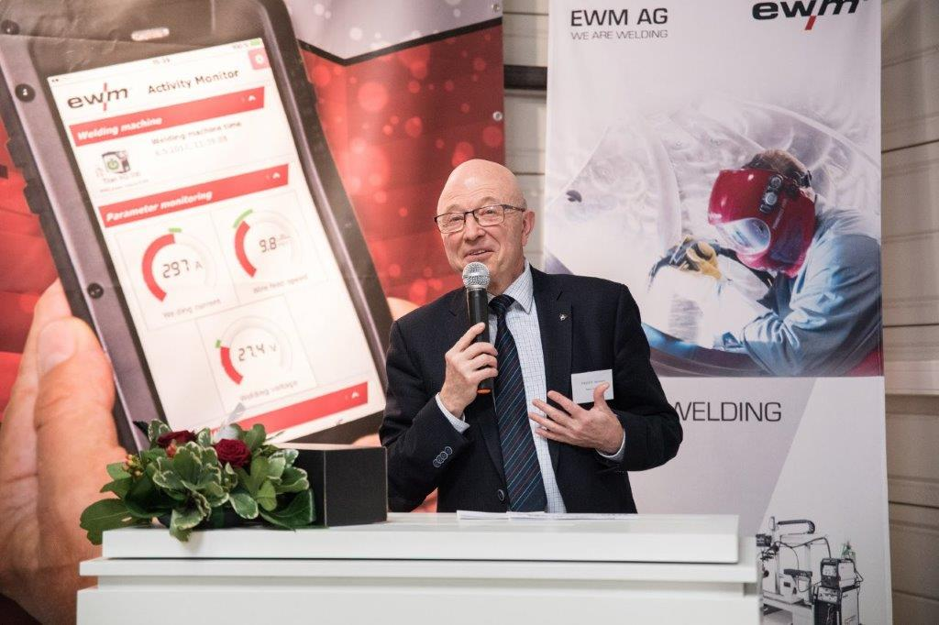

Jean-Pierre Paquien, Deputy Mayor of Rochecorbon, was pleased at EWM’s decision to open a location in the French city.

Fig. 3:

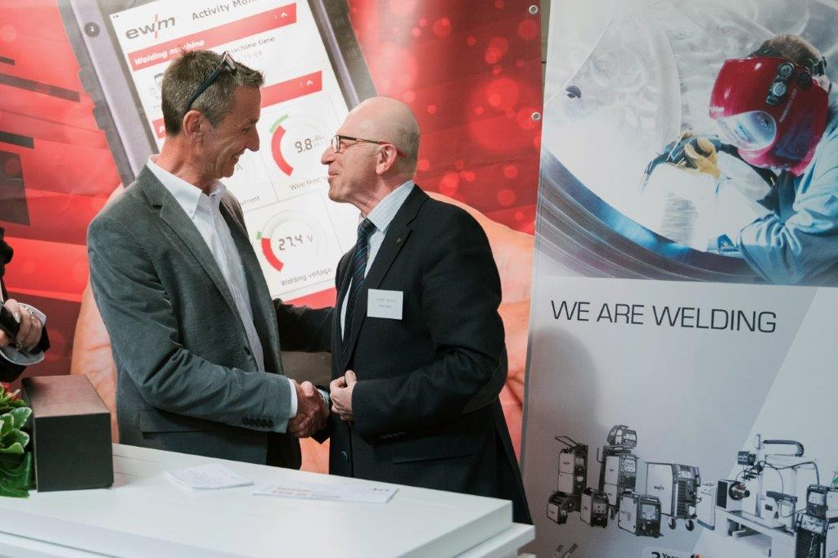

Stéphane Lemaire, Manager of EWM’s new location in Tours, with Jean-Pierre Paquien, Deputy Mayor of Rochecorbon.

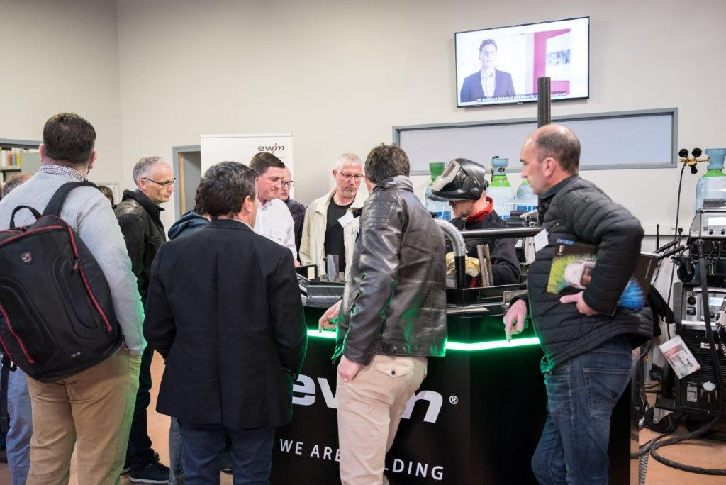Fig. 4:

The guests looked at the various welding and product demonstrations with interest.

About EWM:
EWM AG is Germany’s largest and one of the most important worldwide manufacturers of arc welding technology. The family-run company from Mündersbach has been living its motto, “WE ARE WELDING”, with a great deal of passion for over 60 years, providing forward-looking and sustainable complete solutions for both industrial clients and smaller skilled craft shops.
EWM develops high-end welding technology. The company, based in Germany’s Westerwald region, offers complete systems that cover everything from high-quality welding machines with all required components to welding torches, welding consumables and accessories for manual and automated applications.
Users praise the products’ ease of operation and excellent results. Companies value the solid consultancy, service and enormous savings that come with EWM systems. The welding processes, some of which are patented, reduce the consumption of materials, energy and time during operation and produce up to 75 percent fewer welding fume emissions.
The innovative welding technology manufacturer currently employs around 800 employees at 14 German and 7 international locations, with just under 400 at its original headquarters in Mündersbach.

EWM AG company contact
Maja Wagener
Dr.-Günter-Henle-Str. 8
56271 Mündersbach, Germany
Telephone: +49 2680 181-434
Email: maja.wagener@ewm-group.com
Internet: www.ewm-group.com/en/

Press contact
Jan Leins
additiv pr GmbH & Co. KG
Public relations for logistics, steel, industrial goods and IT
Herzog-Adolf-Straße 3
56410 Montabaur, Germany
Telephone: +49 2602 950 99-16
Email: jl@additiv-pr.de
Internet: www.additiv-pr.de

